Dependent-Samples t-Test – Example 1 (Pigeon’s Schedule of Reinforcement)

Research Question: Which reinforcement schedule elicits more correct responses from pigeons? There are a total of 16 pigeons from 8 clutches (2 pigeons from each clutch). From each clutch, 1 pigeon is assigned to reinforcement schedule A and 1 is assigned to schedule B

Step 1. State your hypotheses.
a. Is it a one-tailed or two-tailed test?

b. Research hypotheses
Alternative hypothesis:

Null hypothesis:

c. Statistical hypotheses

H_{A}:

H₀:

Step 2. Set the significance level ➔ α = .05 Determine t_{crit}. df = ________ t_{crit} = ________

Step 3. Compute the appropriate statistical test.
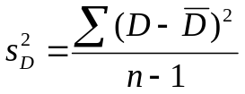
Schedule A | Schedule B | D | 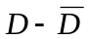 | 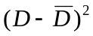
6 | 4
8 | 6
5 | 2
7 | 6 |  |  | 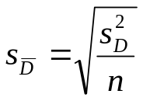
5 | 3
7 | 6
5 | 6
7 | 7
 |  |  |  | 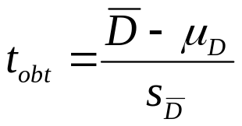

Step 4. Make a decision. Determine whether the value of the test statistic is in the critical region. Draw a picture.

Is the value of the test statistic in the critical region?

Yes No

Step 5. Report the statistical results.

Step 6. Write a conclusion in APA style.

Step 7. Compute the estimated d.

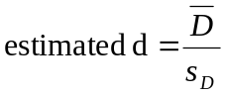
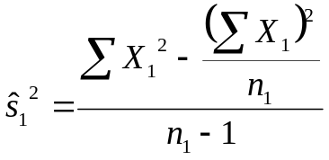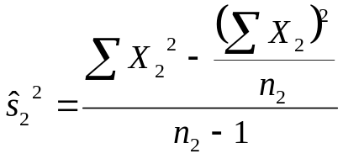

Step 8. Compute r² and write a conclusion.
